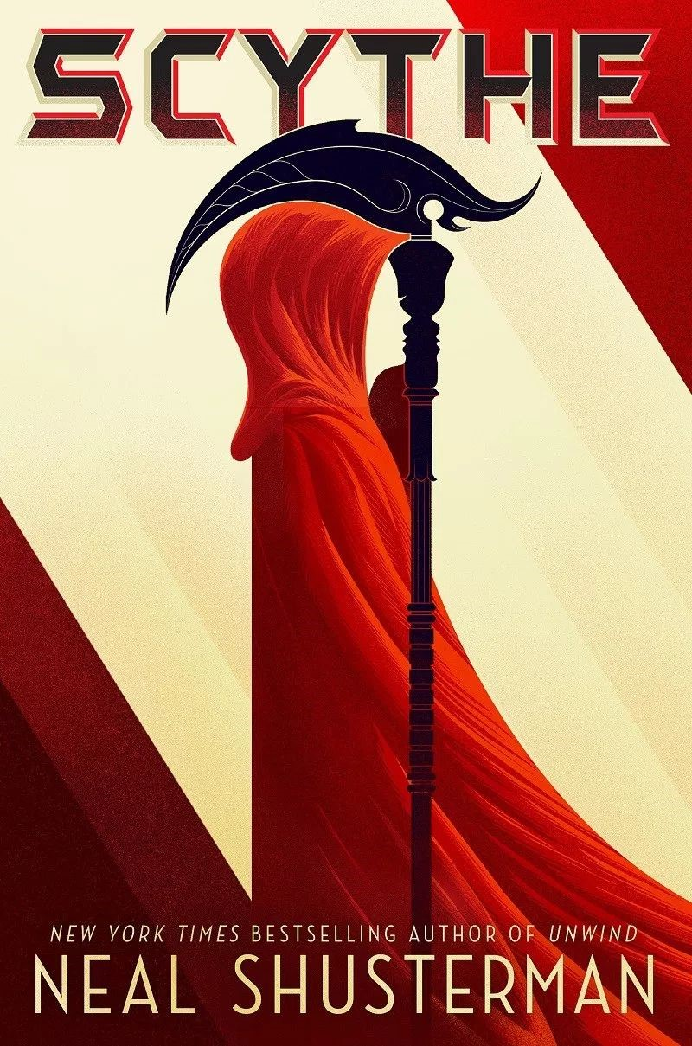

Before Reading:
- Based on the cover and the content of the blurb, predict what you think this book is going to be about.

Novel Study Questions
Gleaning Journal of H.S. Curie
- The first entry from the gleaning journal of H. S. Curie states, “We must, by law, keep a record of the innocents we kill. And as I see it, they’re all innocents. Even the guilty.” Why does Curie see mankind as both innocent and guilty? In your opinion, does that matter?
- It does matter if someone is guilty, this is the basis of the justice sytem
Chapter 1 – No Dimming of the Sun
- Citra thinks, “No surprise that people bent over backwards to please scythes in every possible way. Hope in the shadow of fear is the world’s most powerful motivator.” Do you agree? What role does hope have in motivating others? In what ways do people strive to accommodate and influence scythes?
- I agree that it is reasonable that people are motivated to please sycthes, hope is a good modivator
- So why did Faraday come to Citra’s house that night?
To glean their neibours
Chapter 1 - No Dimming of the Sun - Vocabulary
- Resonant: The visitor’s tone of voice gave him away. Resonant ​and inevitable, like the dull toll of an iron bell, confident in the ability of its peal to reach all those who needed reaching.
  - Definition: deep, clear, and continuing to sound or reverberate.
Gleaning Journal of H.S. Curie

- What world is H.S. Curie referring to, in this journal entry? Use quotes from this entry to show how you know.
The mortal age
Chapter 2 - .303%
- Why does Rowan refer to himself as the “lettuce”?
He brings his family together
- What was the Scythe’s reason for killing Kohl?
He would be likely to die in a car crash in the mortal-age
Chapter 2 - .303% - Vocabulary
- Endure: It was a nice break from the turmoil of his home, which lately had been filled with more relatives than any human being should be expected to endure​ . ​
  - Definition: remain in existance
- Antagonize: The last thing Rowan wanted to do was antagonize ​ a scythe. He should have just slunk off to the attendance​ window, gotten his readmit, and gone to class. But as with the mountain lion, he just had to stand his ground. It was a moment that would change his life.
  - Definition: cause someone to become hostile
Gleaning Journal of H.S. Curie
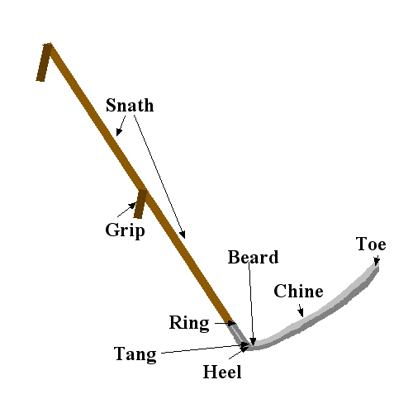
- What was significant about the year 2042?
the year mortality was conquered
Chapter 3 – The Force of Destiny
- What happened to anyone who killed a Scythe?
They and they’re family would be gleaned
- If Citra became a Scythe, what happens to her family?
They would have immunity from being gleaned for her lifetime
Chapter 3 - The Force of Destiny - Vocabulary
- Novelty: In her mind, she had narrowed down the possibilities of her secret admirer. It could be one of five, only two of whom she would enjoy spending an evening alone with. The other three she would endure for the sake of novelty​. ​ There was, after all, some fun to be had spending an evening pretending to be pretentious.
  - Definition: the quality of being new

Gleaning Journal of H.S. Curie
- What was a sign of shame for a Scythe?
- Having your gleanings chosen for you
Gleaning Journal of H.S. Curie - Vocabulary
- Bias: The index is supposed to keep the world free from cultural and genetic bias​, but aren’t there underlying factors that​ we can’t escape? For instance, who decided that the first number of one’s genetic index would be Caucasoid?
  - Definition: inclination or prejudice for or against one person or group
Chapter 4 – Learner’s Permit to Kill
- In Chapter 4, what is the purpose of the paragraphs that are written in ​italics​?
They are thoughts
Chapter 4 - Learner’s Permit to Kill - Vocabulary
- Sabotage: Citra had to tell herself that there was an out. She could fail to perform. She could be a lousy apprentice. She could sabotage ​herself so completely that Honourable Scythe Faraday would be forced to choose Rowan and return her to​ her family at the end of the year.
  - Definition: deliberately destroy, damage, or obstruct
Gleaning Journal of H.S. Curie

- Why was Thunderhead given ultimate power over human government?
Because it was better at governing the human race
- What was the reason why Scythes were created?
Since people could not die overpopulation would ensue

Gleaning Journal of H.S. Curie - Vocabulary
- Corruption: In those days before the Thunderhead, human arrogance, self-interest, and endless infighting determined the rule of law. Inefficient. Imperfect. Vulnerable to all forms of corruption.
  - Definition:
Chapter 5 – But I’m Only Ninety-Six…
- Describe, in your own words, the three types of people did Citra notice as they went through the market.

- Did learning that Scythe Faraday attends the funerals of those he gleans surprise you? For what reason do you think it’s significant that he does this?
It was not very surprising as it fits the character of Faraday very well. It is significant because it shows that he does not take his gleanings easily
Chapter 5 - But I’m Only Ninety-Six…. - Vocabulary
- Blatant: The moment the market doors parted for them and the three of them stepped in, the dread around them was enough to raise gooseflesh on Citra’s arms. Nothing so blatant ​as gasps or screams -- people were used to​ scythes passing through their daily lives. It was silent, but pervasive, as if they had just accidentally strolled onto some theatrical stage and fouled the performance.
  - Definition: obvious or clear
Part Two – No Laws Beyond These
Gleaning Journal of H.S. Curie
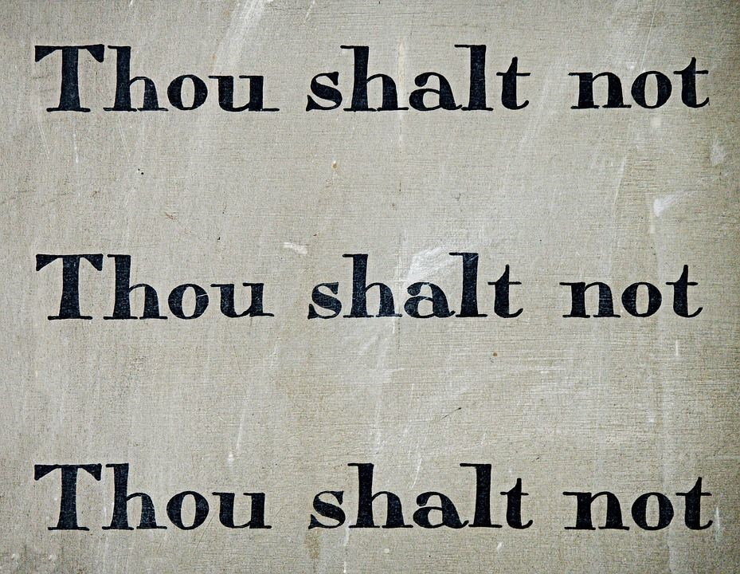
- Review the Scythes’ Commandments. Is there anything about these mandates that you find unusual or surprising?
- no.
Chapter 6 – An Elegy of Scythes
- What order of selection would you have done, and why?
The oldest first
Chapter 6 - An Elegy of Scythes - Vocabulary
- Formidable: “Come now, no indecisiveness. You were decisive enough when you ran to the back of the plane. Bring that formidable ​ will to bear on this moment.” ​
  - Definition: ​ strong and powerful
Chapter 7 – Killcraft
- What archaic weapon was hard to believe it being used today to kill someone?
- What was unique about Faraday’s gleanings?
He used a different weapon with each gleaning
- What was in Citra’s nature despite not wanting to become a Scythe?

Chapter 7 - Killcraft - Vocabulary
- Feigned: “You’re back early,” Scythe Faraday commented when she returned. And although he feigned​ surprise, he had set her place for dinner.
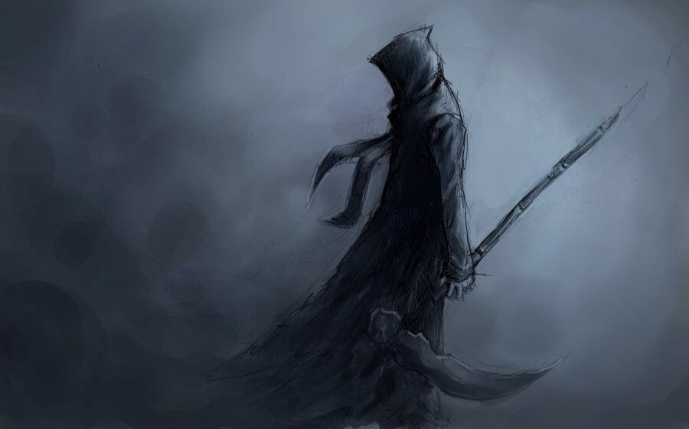
  - Definition:
Chapter 8 – A Matter of Choice
- What happened to a Scythe that tried to access Thunderhead’s conscious mind?
The thunderhead reported him and he was punished
- What were 3 very specific parameters for the next person Faraday would glean?

- What does Rowan mean when he says, “He took the reins of that man’s fear and gave him peace”?
He means that he was somewhat controlled and then he stopped being scared
Chapter 8 - A Matter of Choice - Vocabulary
- Visceral: Rowan’s task was not as visceral​ but was even more troubling. ​
  - Definition: bloody/violent

Gleaning Journal of H.S. Curie

- Why is human nature considered to be a virus?
Gleaning Journal of H.S. Curie - Vocabulary
- Vigilant: It reminds me that in spite of our lofty ideals and the many safeguards to protect the Scythedom from corruption and depravity, we must always be vigilant​, because power come infected​ with the only disease left to us: the virus called human nature.
  - Definition: conisous/aware
Chapter 9 – Esme
- What do you think the four scythes have planned for Esme?
To keep hostage against big chungas scythe
Chapter 9 – Esme - Vocabulary
- Negotiating: She was negotiating ​the cheese, trying to figure out how to take that first bite without​ burning the roof of her mouth, when the scythes arrived. Her back was to them, so she didn’t see them at first. But she heard them - or at least one of them.
  - Definition:
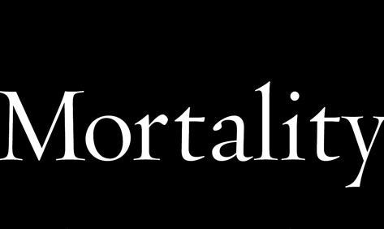
Gleaning Journal of H.S. Curie
- Why would equal wealth add to the plague of boredom that afflicts the immortal?
Because wealth is what people use to strive before that has been taken away
Gleaning Journal of H.S. Curie - Vocabulary
- Forging: When I look at news archives from the Age of Mortality, it seems people had more reasons to do the things they did. Life was about forging ​time, not just passing it. ​
  - Definition: illiagally copy signigures
Chapter 10 – Forbidden Responses
- What did Tyger mean when he said, “Dude, you’re not lettuce anymore, you’re deadly nightshade. You’re the mean greens now!”
rowen has become stronger and more deadly
- What would you give up if you were a scythe?
Chapter 10 – Forbidden Responses - Vocabulary
- Liability: Tyger, Rowan knew was the very definition of “bad idea.” That had always been part of the fun of being his friend. But now that was a major liability. Rowan grabbed Tyger’s arm, kicked him behind the knee to buckle his leg, and spun him to the ground --- all in a single Bokator move.
  - Definition: to be blamable
Gleaning Journal of H.S. Curie

- What remains mortal, while mankind became eternal?
- love
Chapter 11 – Indiscretions
- What happened to her hand when she put on his ring?
Her finger got frozen
- Why did Faraday tell Citra to tell Rowan to begin bringing his nightly warm milk?
To see when he would take the ring

Chapter 11 – Indiscretions - Vocabulary
- Dubious: She was dubious​, but did as she was told, because in spite of what she told him, she did​ want to try it on.
  - Definition: in doubt
Gleaning Journal of H.S. Curie
- What did H.S. Curie say had become irrelevant after people conquered death?
Aspiitions of some sort
Gleaning Journal of H.S. Curie - Vocabulary
- Lament: Sometimes, when the weight of my job becomes overwhelming, I begin to lament ​ all the things lost when we​ conquered death.
  - Definition: a passionate expression of grief or sorrow
Chapter 12 – No Room for Mediocrity

- What were the 3 things Scythes did during a conclave?
Cult water washing
argue
test the apprentice scythes
- What did Citra say that made Rowan think that she might not hate him as much as he thought?

Chapter 12 - No Room for Mediocrity - Vocabulary
- Mediocrity: There was no room for mediocrity​ , especially now with conclave coming up.​

  - Definition: averagely
Chapter 13 – Vernal Conclave
- Who was Scythe Curie known for gleaning?
The stagnant
- What was the toll of the names?
Reading the names of the gleaned
- What did Faraday believe about the anonymous note accusing Goddard of unnecessary cruelty in gleanings?
- Goddard wrote it himself

Chapter 13 – Vernal Conclave - Vocabulary
- Homage: It was an unyielding homage ​ to ancient Greece and Imperial Rome, the birthing grounds of civilization.
  - Definition: special honour or respect shown publicly.
Gleaning Journal of H.S. Curie - Vocabulary
- Slavish: Or will boredom and slavish routine plague us even more than it does today, giving us less of a reason to live limitless lives? I dream of the former; but suspect the latter.
  - Definition: like a slave
Chapter 14 –A Slight Stipulation
- What was unusual about the apprentice’s exam?
They fought?
- What did Scythe Rand propose about Faraday’s 2 apprentices that had never been done?
Make them glean the other
Chapter 14 – A Slight Stipulation - Vocabulary
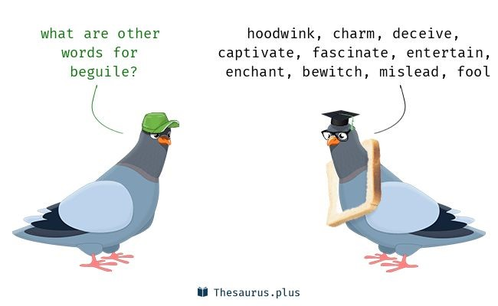
- Stipulate: Scythe Faraday rose to his feet as if launched from his chair. “I object!” he shouted. “This conclave cannot stipulate ​how I train my apprentices! It is my sole right to teach them, train them, and​ discipline them!”
  - Definition: to tell
Gleaning Journal of H.S. Curie
- What do the Scythes not have access to from Thunderhead?
- They are suposted to be seporate from the thunderhead
Chapter 15 –The Space Between
- Based on your initial impressions of Scythe Faraday, how would you describe him? Do you think his leadership style will impact Citra or Rowan?
He is a true gamer who does true gamer moves
Chapter 15 – The Space Between - Vocabulary
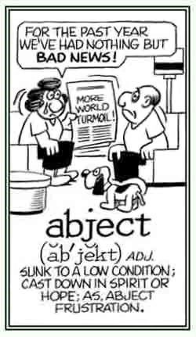
- Abject: Whoever wins will begin their life as a scythe in abject​ sorrow, never to forget the cost of that ring.
  - Definition: areness
- Perverse: He wanted to reach for her, maybe touch her cheek. But thinking about that made him think of the saleswoman who was gleaned by a touch. What a perverse ​ poison that was. ​
  - Definition: terrible
Gleaning Journal of Goddard
- Provide two differences between Scythe Curie and Scythe Goddard.
One does not were a blue robe, the other does
one enjoys killing, the other does not

Chapter 16 – Pool Boy
- Describe Maxim Easley’s company.

Chapter 16 – Pool Boy - Vocabulary
- Opulence: The diamond-studded scythe and his rainbow of subordinates followed, looking around at the understated opulence ​of the mansion. ​
  - Definition:
Chapter 17 – The Seventh Commandment
- What did the author mean when he said, “High Blade Xenocrates was a bloated bundle of contradictions.”?
He was not very cabable
Chapter 17 – The Seventh Commandment - Vocabulary
- Admonishment: They approached the door, steeling themselves for admonishment​. ​
  - Definition: suprised



Part 3 – The Old Guard and The New Order
Chapter 18 – Falling Water
- What caused Scythe Curie to yell at Citra and have her lay down on the pavement after a gleaning?
Citra question her
- Why did Scythe Curie take on Citra as her apprentice?
Because faraday committed big oof
Chapter 18 – Falling Water - Vocabulary
- Vicinity: “I didn’t. I cooked for me. Your grumbling stomach just happened to be in the vicinity​.“
  - Definition: close by, near
- Substantial: While Scythe Faraday always reviewed his notes on his chosen subject and used public transportation, Scythe Curie had an old-school sports car that required substantial​ skill to drive -- especially on a winding mountain​ road.
  - Definition: with substance
Gleaning Journal of H.S. Curie

- Explain what Scythe Curie said about immortality changing humans, with evidence from the text.
Chapter 19 – A Terrible Thing To Do
- What did Scythe Curie tell Citra about Thunderhead seeing everything?
To inform her of the truth
- What event does Citra now feel might be an issue with Faraday’s death?

Chapter 19 – A Terrible Thing To Do - Vocabulary
- Delusion: Citra was in the same dance class, back in that magical childhood time when little girls nurtured the delusion​ that they were as graceful as they were cute. ​

  - Definition: hallucination
Chapter 20 – Guest of Honour
- What had Rowan decided about his situation as apprentice to Scythe Goddard?
That he was going to die
Chapter 20 – Guest of Honour - Vocabulary
- Obsolete: “And I couldn’t care less how Scythe Nehru feels. Old-guard scythes have obsolete​ ideas. ​ They’re too set in their ways to see the wisdom of the Change.”
  - Definition: with use
- Benefactors: “Correct,” said Scythe Goddard brightly. “And I own none of this. The food is donated by generous benefactors​ , the guests are here by choice, and this find estate has been graciously loaned to​ me for as long as I choose to grace its halls.”
  - Definition: people whom gain for an event

Gleaning Journal of H.S. Curie - Vocabulary
- Annihilation: But I wonder more about the imposter. What was it they hoped to achieve? Was it the lure of the forbidden? Were they enticed by the danger of being caught? Or did they simply wish to leave this life so badly that they chose one of the few direct paths to annihilation?
  - Definition: destroy
Chapter 21 – Branded
- Why was Rowan in so much pain after Goddard’s scythes beat him to a pulp?
Because his pain nanites turned off
Chapter 21 – Branded - Vocabulary
- Revelry: In less than an hour the guests had left, and servants began to clean the detritus of revelry​ from the eerily silent grounds.
  - Definition:
- Afoul: Yet Goddard gave orders that anyone who ran afoul​ of her would be severely disciplined. ​
  - Definition: plot to do bad
Chapter 22 – Signs of the Bident
- What was unusual about Citra’s job to notify the only family member of Marissa Ferguson?


- What word did Brother Ferguson use that was also used by Scythe Curie?
Chapter 22 – Signs of the Bident - Vocabulary
- Bereaved: Most of the bereaved​ that Citra had to notify were the same: husbands, wives, children, parents.
  - Definition:
Chapter 22 – Signs of the Bident - Figurative Language
Highlight the figurative language, identify the type of figurative language, explain how you know it is a _________ (simile...for example), and explain what the figurative speech means.
- She would watch as the scythe prowled the streets and malls and parks, becoming like a lioness in search of vulnerable prey.
  - Figurative Language: an anolgy what the truth is
  - How do you know? Big brain
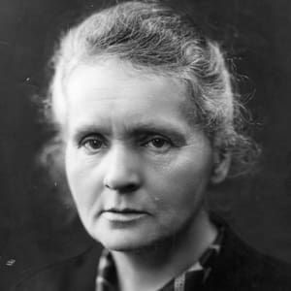
  - Explanation:
Gleaning Journal of Goddard
- What image did Goddard compare himself and other scythes to?
Not serial killers
Chapter 23 – The Virtual Rabbit Hole
- What was the reason Citra was looking through data files of public camera systems?
To find the reason of faradays death
- Who was Marie Curie?
Citra’s master
Chapter 23 – The Virtual Rabbit Hole - Vocabulary
- Denser: The small talk was of the microscopic variety, and although it was good to be with her family, never had the barrier between them felt denser​ . ​
  - Definition: more dense
Chapter 23 – The Virtual Rabbit Hole - Figurative Language
Highlight the figurative language, identify the type of figurative language, explain how you know it is a _________ (simile...for example), and explain what the figurative speech means.
- A faint sense of longing tugged at her, but she couldn’t be sure what she longed for.
  - Figurative Language: a tug
  - How do you know? Cause no one is tugging her
  - Explanation:
Chapter 24 – An Embarrassment to Who and What We Are

- How did Rowan feel after the gleanings?
Not happy
Chapter 24 – An Embarrassment to Who and What We Are -
Vocabulary
- Dissent: Goddard’s pontifications were constant, and although Rowan often disagreed, he didn’t argue or voice his dissent
  - Definition:
Chapter 24 – An Embarrassment to Who and What We Are - Figurative Language
Highlight the figurative language, identify the type of figurative language, explain how you know it is a _________ (simile...for example), and explain what the figurative speech means.
- It was a place of royal blue studded with diamonds that glistened like stars.
  - Figurative Language: stars
  - How do you know? There not stars
  - Explanation:
- And then there were the parties. They came upon the state like seizures. Everything else stopped.
  - Figurative Language:
  - How do you know?
  - Explanation:
Journal of Rowan Damisch, scythe apprentice

- How has Rowan grown as an apprentice through Scythe Goddard?
stronger
Chapter 25 - Proxy of Death
- What project did Thunderhead move forward on discreetly so as to not draw public attention?
Trying to not commit big oof
- What did Rowan do that Goddard and his scythes were not aware of?
Not like them
Chapter 25 - Proxy of Death - Vocabulary
- Siege: Until the day a team of scythes laid siege​ to his research facility. ​
  - Definition: invade
Chapter 25 - Proxy of Death - Figurative Language
Highlight the figurative language, identify the type of figurative language, explain how you know it is a _________ (simile . . . for example), and explain what the figurative speech means.
- Too loud to hear Rowan over the chopper blades, which made the scythes’ robes flail like flags in a storm as they crossed the lawn.
  - Figurative Language: flags
  - How do you know? No flags
  - Explanation:
Gleaning Journal of H.S. Prometheus

- What did H.S. Prometheus hope the 10 laws would help them avoid?
The law
Chapter 26 – Not Like the Others
- What did Rowan learn about Volta?
He is not like the others
- Explain Volta’s reaction to the gleanings.
Not happy
Chapter 26 – Not Like the Others - Vocabulary
- Face value: She accepted her situation at face value, ​ and never spoke ill of her benefactor -- or more​ accurately, her captor, for she was clearly Goddard’s prisoner, even though she might not see it that way.
  - Definition: clear worth
Chapter 26 – Not Like the Others - Figurative Language
Highlight the figurative language, identify the type of figurative language, explain how you know it is a _________ (simile...for example), and explain what the figurative speech means.
- Goddard ate enough for everyone. He was invigorated by the day’s hunt, like a vampire sucking in the life force of its victims.
  - Figurative Language:
  - How do you know?
  - Explanation:
- Rowan knew he was out on a limb with Volta. The only thing to do was shimmy to its precarious end.
  - Figurative Language:
  - How do you know?
  - Explanation:
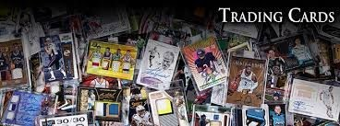
Gleaning Journal of H.S. Curie - Vocabulary
- Notoriety: Notoriety​ and infamy quickly evolve into celebrity and​ fame for scythes - and the most brazen acts harden further into legend.
  - Definition:
Chapter 27 – Harvest Conclave
- What was the difference between Goddard and Rowan’s entrance versus Citra and Curie’s entrance to the Harvest conclave?
- Why was Scythe Curie so tense at the Harvest conclave?
- Using a Venn diagram, compare the apprenticing experiences of Rowan and Citra.
Chapter 27 – Harvest Conclave - Vocabulary
- Pensive: “The world has a talent for rewarding bad behaviour with stardom,” Scythe Curie said, as she viewed some of the videos that had been uploaded. Then she got a bit pensive​. “I know the pitfalls of​ being a celebrity scythe,” she confessed, although Citra already knew.
  - Definition:
Gleaning Journal of H.S. Curie
- What did Scythe Curie wonder about Thunderhead if the Scythes decided on another global gleaning?
Chapter 28 – Hydrogen Burning in the Heart of the Sun
- What was Scythe Goddard’s reaction to Rowan’s actions are the Harvest Conclave?
- What did Volta indirectly tell Rowan about Esme?
Chapter 28 – Hydrogen Burning in the Heart of the Sun - Vocabulary
- Flamboyance: Scythe Goddard was all flamboyance​ and bright chatter. ​
  - Definition:
- Inconspicuous: He seemed self-conscious and tried to be inconspicuous​, but a man of such mighty​ girth, festooned in gold, was hard not to see.
  - Definition:
Chapter 28 – Hydrogen Burning in the Heart of the Sun - Figurative Language
Highlight the figurative language, identify the type of figurative language, explain how you know it is a _________ (simile...for example), and explain what the figurative speech means.
- Chomsky was the brainless brawn, Rand was the animus - the wild force of nature among them.
  - Figurative Language:
  - How do you know?
  - Explanation:
Journal of Rowan Damisch, scythe apprentice
- Rowan wants to repay Scythe Goddard for what he deserves in return for all that he’s done for him. What do you think that Rowan means by this?

Chapter 29 – They Called It Prison
- What did Scythe Mandela show Citra that was the convincing evidence of her guilt?
- Who took care of removing Citra’s body to the revival centre that outraged the High Blade?
Chapter 29 – They Called It Prison - Vocabulary
- Nonrevocable: Immunity is nonrevocable​, even in a case such as this. Therefore, you will be held in an​incarceration facility until that time.
  - Definition:

Part 4 – Midmerican Fugitive
Chapter 30 – Dialogue with the Dead
- Why does the Thunderhead speak to Citra?
- What name does Thunderhead give to Citra concerning Faraday’s death? What are your predictions of this name?
Chapter 30 – Dialogue with the Dead - Vocabulary
- Pivotal: Nevertheless, I’ve been running algorithms on the possible future of the Scythedom, and found something very curious. In a large percentage of possible futures, you play a pivotal​ role. ​

  - Definition:

Gleaning Journal of H.S. Curie - Vocabulary
- Stagnation: I saw no interminable stagnation​ in this woman, so instead of gleaning her I had her kiss​ my ring. The immunity was immediate and irrevocable - so she could no longer entertain thoughts of being gleaned for a full year.
  - Definition:
Chapter 31 – A Streak of Unrelenting Foolishness
- What did Curie reveal to Citra about her relationship with Faraday after they both had been Scythes for a long time?
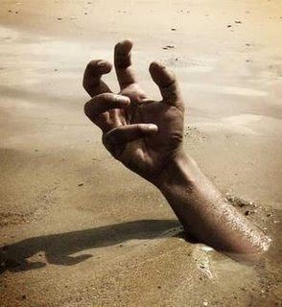
- Who did Curie send Citra to while she tried to clear her name?
Chapter 31 – A Streak of Unrelenting Foolishness - Figurative Language
Highlight the figurative language, identify the type of figurative language, explain how you know it is a _________ (simile...for example), and explain what the figurative speech means.
- At last numbness began to overtake her, and she felt sleep begin to envelop her like quicksand . . .
  - Figurative Language:
  - How do you know?
  - Explanation:
Chapter 32 – Troubled Pilgrimage
- What is a Tonist?
- How was Citra saved from the Chilargentine Scythes on the train?
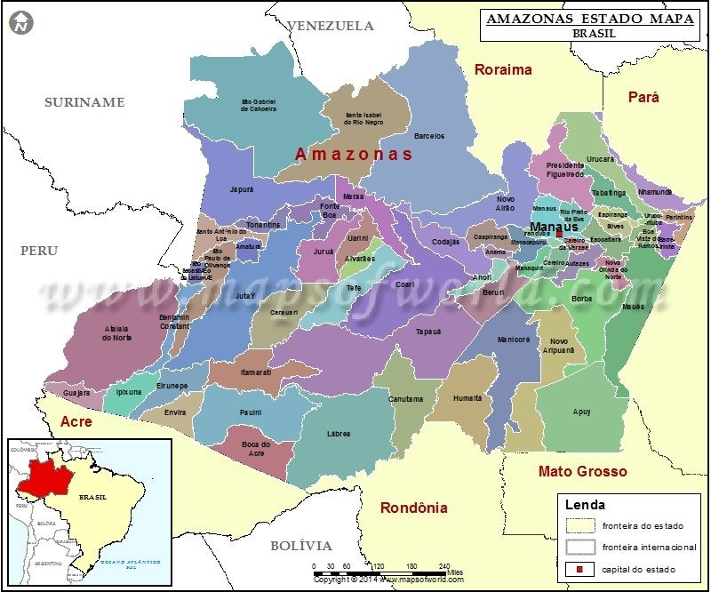
Chapter 32 – Troubled Pilgrimage - Vocabulary
- Quest: “My quest​?” ​
“Don't all wandering pilgrims have quests?” ​
“Yes,” she said, “I . . . seek an answer to the burning question: Is it A-flat or G-sharp?”
  - Definition:
Chapter 32 – Troubled Pilgrimage - Figurative Language
Highlight the figurative language, identify the type of figurative language, explain how you know it is a _________ (simile...for example), and explain what the figurative speech means.
- She realized she had to cut a weaving course, like cargo ships in mortal-age wartime, to throw them off her path to keep them from anticipating where she’d be next.
  - Figurative Language:
  - How do you know?
  - Explanation:
Chapter 33 – Both the Messenger and the Messenger
- Citra became so committed to understanding the details of Faraday’s last day, which led her to Scythe Faraday. Do you think she was right to grow suspicious about his death?
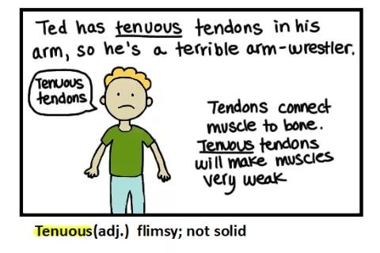
Chapter 33 – Both the Messenger and the Messenger - Vocabulary
- Complacent: “To think I was complacent​ here, while all this was going on.” ​
  - Definition:
Chapter 34 – The Second Most Painful Thing You’ll Ever Have to Do
- What would be the second most painful think Citra will ever do? What do you propose will be the first?
Chapter 34 – The Second Most Painful Thing You’ll Ever Have to Do - Vocabulary
- Inept: There were times when the training called for them to run, or even fight back. Most were inept​ at it, but some had clearly been trained in combat.
  - Definition:
Chapter 34 – The Second Most Painful Thing You’ll Ever Have to Do - Figurative Language
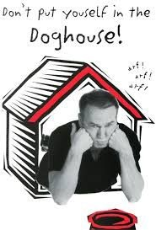
Highlight the figurative language, identify the type of figurative language, explain how you know it is a _________ (simile...for example), and explain what the figurative speech means.

- “You have excelled beyond my wildest expectations,” Goddard told him. “I suspected you had a spark in you, but never dreamed it would be such an inferno!”
  - Figurative Language:
  - How do you know?
  - Explanation:
- Scythe Volta was now in the doghouse, though, because he had lobbed a container of poison gas into the burning maze.
  - Figurative Language:
  - How do you know?
  - Explanation:
Chapter 35 – Obliteration is our Hallmark
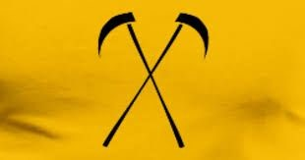
- Rowan became lettuce again. Non-sentient and secondary. Easily ignored and forgotten. What did he mean by this?
- Where did Goddard and his scythes take Rowan to perform is first gleaning, even though he was still an apprentice?
Chapter 35 – Obliteration is our Hallmark - Vocabulary
- Bias: “But this . . . this breaks the second commandment. It clearly shows bias​.” ​
  - Definition:
- Travesty: “Precisely,” agreed Goddard. “They’ve made a mockery of mortal age faith. Religion is a cherished part of history, and they’ve turned it into a travesty​.” ​
  - Definition:
Chapter 35 – Obliteration is our Hallmark - Figurative Language
Highlight the figurative language, identify the type of figurative language, explain how you know it is a _________ (simile...for example), and explain what the figurative speech means.
- His head came to rest on Rowan’s shoulder, while all around them distant cries of agony filled the icy air.
  - Figurative Language:
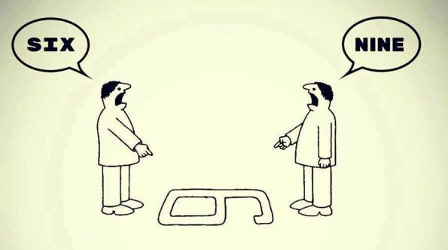
  - How do you know?
  - Explanation:
Gleaning Journal of H.S. Faraday - Vocabulary
- Empathy: For only the pain of empathy will keep us human.
  - Definition:
Chapter 36 – The Thirteenth Kill
- What did Rowan tell the firefighters so that they would not put out the fire at the Tonist community?
Chapter 36 – The Thirteenth Kill - Vocabulary
- Carnage: Rowan strode closer, ignoring the carnage​ around him, focusing on Goddard. “Let him go,” Rowan said.
  - Definition:
Chapter 36 – The Thirteenth Kill - Figurative Language
Highlight the figurative language, identify the type of figurative language, explain how you know it is a _________ (simile...for example), and explain what the figurative speech means.
- Chomsky set Rowan’s arm ablaze with the flamethrower, but Rowan rolled on the ground, putting it out, then grabbed the toning mallet from beside the altar and brought it down on Chomsky like the hammer of Thor, striking again and again and again as if he were toning the hour, until curate grabbed his hand to stop him and said, “That’s enough, son. He’s dead.”
  - Figurative Language:
  - How do you know?
  - Explanation:
Part Five – Scythehood
Chapter 37 – Shaking the Tree
- In Chapter 37, the text says, “Xenocrates got down to the real reason he had come: To shake the tree and see what, if anything, would fall out.” What did Rowan mean by this?

- What mutual agreement did the High Blade and Rowan come to regarding the investigation and Esme?
Chapter 37 – Shaking the Tree - Vocabulary
- Nullifies: “All the other scythes must see me as very bad luck. After all, I’ve gone through two scythes in one year. I suppose this nullifies​ my apprenticeship.” ​
  - Definition:
Gleaning Journal of H.S. Prometheus the first World Supreme Blade
- What did Prometheus say about the achievement of Scythehood?
Gleaning Journal of H.S. Prometheus the first World Supreme Blade - Vocabulary
- Stoic: The power of life and death cannot be handed out blithely, but only with stoic​ and weighty​ reserve.
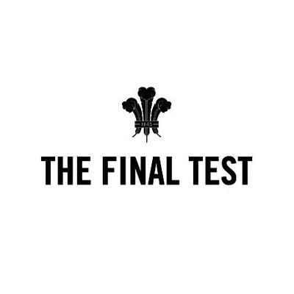
  - Definition:
Chapter 38 – The Final Test
- What did Citra do for Ben before she gleaned him?
- What did Citra find out about the other two candidates and Rowan’s test?
Chapter 38 – The Final Test - Vocabulary
- Coerced: “You may not be coerced​ into doing this. You may take all the time you need. You must use​ the weapon assigned. When you are done, you will leave the subject and approach the committee to be assess on your performance.”
  - Definition:
Chapter 39 – Winter Conclave
- What was the heated debate about concerning gleaning methods?
Chapter 39 – Winter Conclave - Vocabulary
- Resonance: “in the wake of the Tonist tragedy, conclave takes on a certain . . . resonance​, don’t you​ think?” she heard someone say. “No pun intended.” But of course, it was.
  - Definition:
- Deluding: If she was deluding​ herself, at least it would allow her to get through this awful day. ​
  - Definition:
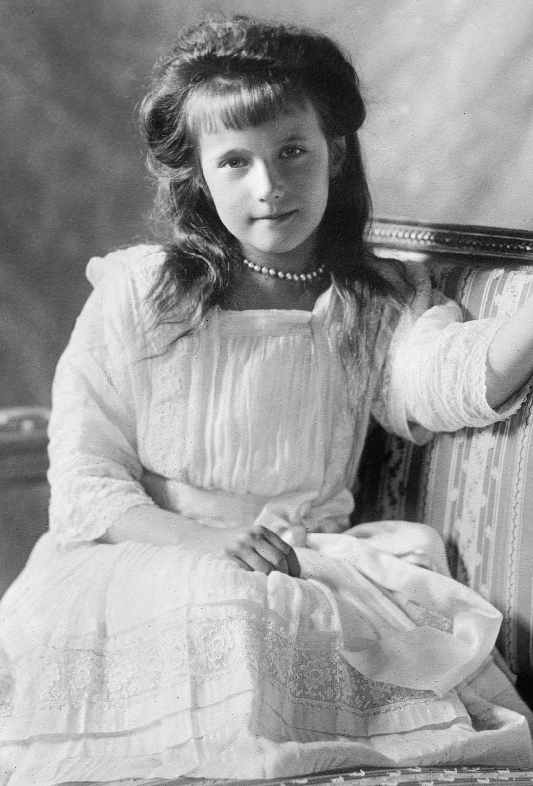
Chapter 40 – The Ordained
- What was her new Patron Historic name?
- What did Citra do to Rowan that “accidentally” gave him one-year immunity?
Chapter 40 – The Ordained - Vocabulary
- Stoic: Citra maintained a stoic​ facade, refusing to let the adrenaline flooding her system reveal itself on​ her face.
  - Definition:
- Edict: The scythes began to calm down, and Xenocrates pointed an accusing finger. “Citr---uh . . . that is Scythe Anastasia --- you have blatantly violated a Scythedom edict​!​”
  - Definition:
Gleaning Journal of H.S. Anastasia
- Scythe Anastasia hopes that Scythe Lucifer will see her as one of the good scythes if he would ever come her way. Who do you think Scythe Lucifer is?
- Given the ending of Scythe​, share your predictions for the next instalment of this thrilling series.

Part 6 – Dialectical Journal
- Characterization (Citra) - Find at least 3 pieces of evidence throughout the novel that help to define the character of Citra. Choose quotes that show change or growth that takes place​; the evidence​ should be chosen from the beginning​, ​ middle​, and ​end ​of the book. ​Comment on the importance and/or​ significance of each piece of evidence and what it shows us about our protagonist(s).
- Evidence: Citra - Beginning | - Commentary:
- Evidence: Citra- Middle | - Commentary:
- Evidence: Citra- End | - Commentary:

- Characterization (Rowan) - Find at least 3 pieces of evidence throughout the novel that help to define the character of Rowan. Choose quotes that show change or growth that takes place​; the evidence​ should be chosen from the beginning, ​ middle​, and ​end ​of the book. ​Comment on the importance and/or​ significance of each piece of evidence and what it shows us about our protagonist(s).
- Evidence: Rowan - Beginning z | - Commentary:
- Evidence: Rowan- Middle | - Commentary:
- Evidence: Rowan- End | - Commentary:

- Characterization (Others) - Next, consider how the remaining characters of Scythe Faraday, Scythe Goddard, ​ and Scythe Curie affect Citra and/or Rowan, the person she/he is, and who she/he becomes. ​Create an entry​ for three of the characters that you feel impact Citra/Rowan the most. Choose at least one piece of evidence per character then comment on how the character is defined by his or her words/actions, AND how Citra/Rowan is affected by knowing and living with or without the character.
- Evidence: Scythe Faraday | - Commentary:
- Evidence: Scythe Goddard | - Commentary:
- Evidence: Scythe Curie | - Commentary:

